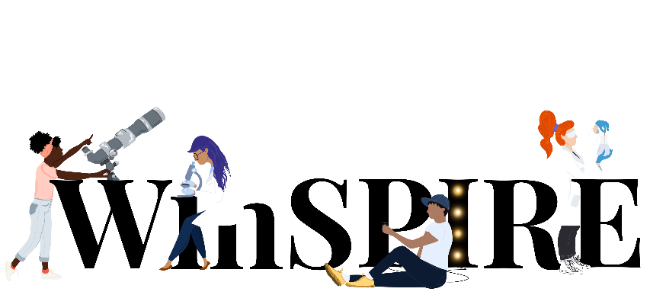

Community Solutions Challenge

Official Rulebook
2025-2026

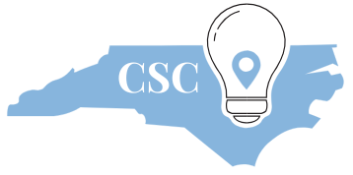

A Welcome Message
Dear Participants,
This rulebook sets the foundation for the first annual competition season of WinSPIRE’s Community Solutions Challenge at the University of North Carolina at Chapel Hill. This competition encourages high school students from across the state of North Carolina to identify and propose solutions to a pertinent problem in their community using methodologies rooted in science, technology, engineering, and math (STEM).
To everyone participating, welcome! Here’s to a group of problem solvers and innovators.
Welcome to The Hill.
Sincerely,

Sanika Dolas
Arya Mehta
Shriya Rajesh
WinSPIRE Community Solutions Challenge Team
University of North Carolina at Chapel Hill

Table of Contents
About WinSPIRE at UNC 5
Who is WinSPIRE? 5
Why the CSC initiative? 5
About the Community Solution Challenge (CSC) 6
What is the CSC? 6
CSC Important Dates: 7
CSC Topic Areas: 7
Participant Eligibility: 8
CSC Program Guidelines & Format: 9
Team formation: 9
Team Registration: 9
Document submission: 10
Final competition: 12
Event timeline: 14
Competition winners & teams who participate all year: 15
AI Policy: 15
FAQs 16
I am a high schooler at a registered high school but am not of high school age. Am I still eligible to participate? 16
How will we communicate with you? 16
I cannot attend every single workshop on the dates and times stated. Are they mandatory? 16
How is attendance being tracked for Team Certificates? 16

​

About WinSPIRE at UNC

Who is WinSPIRE?
The WinSPIRE Organization is a volunteer-led organization at the University of North Carolina at Chapel Hill (UNC-CH) that provides training, experience in STEM research, and mentorship to high school students. WinSPIRE is dedicated to creating spaces where all people can thrive. Our primary approach to fulfilling these goals has been through our 6-week in-person Summer Research Program. Through this programming, we not only provide high school students with hands-on research experience at UNC-CH, but we also provide training to UNC-CH researchers to ensure those actively involved in STEM research have the tools necessary to make inclusive and safe spaces for the next generation.

Why the CSC initiative?
The goal of the Community Solutions Challenge is to increase access to STEM education and opportunities for high school students across North Carolina. We aim to provide advanced knowledge of the scientific process that replicates real-world research and to celebrate the diversity of communities across North Carolina by engaging them in community-minded projects.
Research opportunities for high school students can be difficult to find and hard to obtain, and their availability is often skewed towards communities with existing resources. We are committed to lowering the barriers to STEM research at the high school level across the state by allowing students to experience aspects of real-world research at no cost and within their own high schools. Through the Community Solutions Challenge, high schoolers will be able to engage with researchers from UNC-CH, learn valuable skills on how to apply the scientific method to solve an important issue, and become more proficient in reading and writing in a scientific context. This will be accomplished through our year-long workshop series which concludes with a competition day.
We are passionate about making outreach opportunities easy to access and open to everyone, because we believe every student has something valuable to offer. Your ideas, experiences, and voice matter—and they can help make your communities stronger.

About the Community Solution Challenge (CSC)

What is the CSC?
The Community Solutions Challenge is meant to be a platform for students to positively impact their community using science. The goal is to collaborate with peers to create a STEM-based solution to a local problem. THE CSC hopes to support the array of communities throughout North Carolina by asking high school students to ponder how their community functions and how they can help make it thrive. The CSC team believes that everyone has the capacity to be a scientist and push for change in their communities.
The Community Solutions Challenge is designed to encourage students to become more engaged in their communities by identifying an impactful problem that they think could be addressed with science, technology, engineering, or math (STEM) approaches. Participating CSC students will collaborate with their peers to develop STEM-based solutions to these issues and propose them to the WinSPIRE CSC group in written and in-person or virtual formats. The CSC hopes to embrace the unique communities across North Carolina and encourages participants to do the same when they begin thinking about solutions to problems in their respective communities. The WinSPIRE CSC believes that everyone has the capacity to be a scientist and push for change in their communities. Through the CSC, participants will gain knowledge of how the scientific process works and how to best approach designing a solution through our workshop series led by scientists at UNC.
Participants will first identify a community problem they are invested in, and work with their peers towards solving it creatively. In the initial stages (Fall 2025), competitors will draft a Letter of Intent (LOI) highlighting their chosen issue, describing their research/work done towards developing a solution, and briefly discussing what the team’s proposed solution is. In the months leading up to the in-person competition (Spring 2026), participants will further flesh out their proposed solutions, draft them into a grant proposal, and create a short pitch to present at the final competition. Throughout this process, we aim to guide students int the scientific process and help them envision how they can make a lasting impact in their communities.

CSC Important Dates:
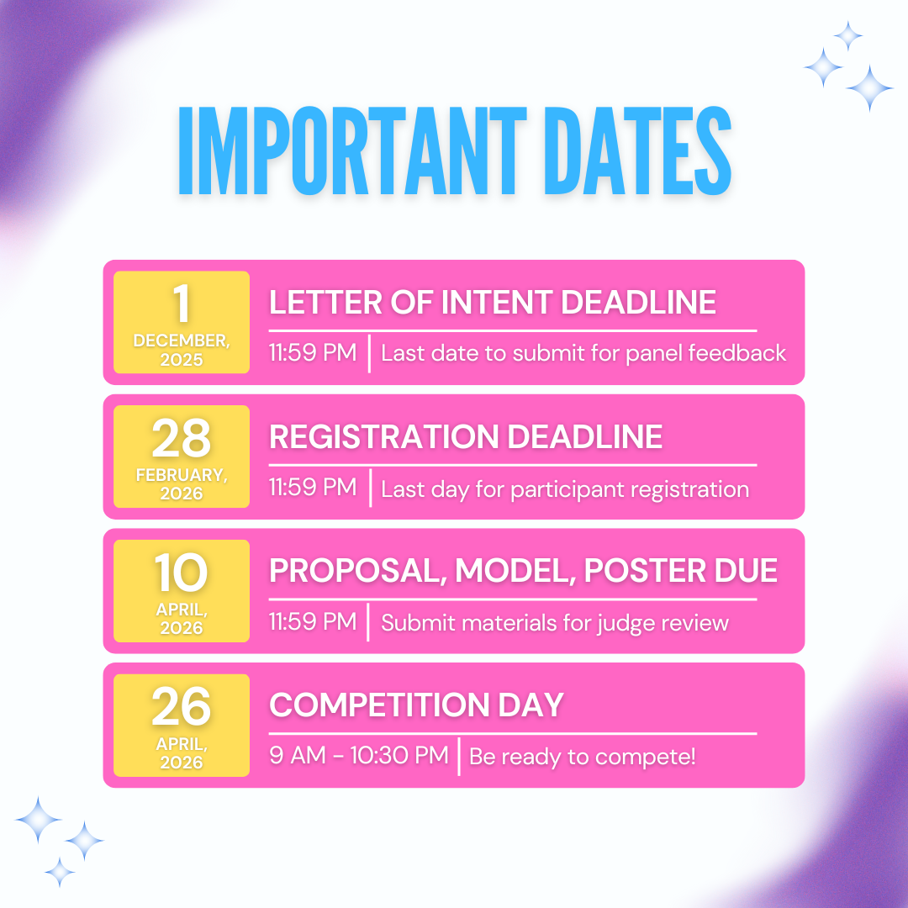

CSC Topic Areas:
The solutions your team proposes can be from any STEM discipline* and will be judged based on the nature of their topic.
*Possible Topic Areas- Students can choose to focus on a community solution based on any of the following topics. Some examples are listed below, but please try to think of your own; these are provided for your reference.
- Agriculture/Animal Sciences
  - Example: Epidemics in local farms. Addressed with diagnostic tests and treatments.
- Architecture/Engineering/Physics
  - Example: Infrastructure during severe weather events. Addressed with more structurally sound or efficient structures.
- Astronomy
- Behavioral Sciences/Psychology
- Biology/Biomedical Sciences
- Computer Science/Software
- COVID-19
- Ecology/Environmental Sciences/Conservation
- Economics
- Education
- Public Health/Policy
- Other (see note below)
Above, we listed a few categories that are currently bold or labeled “Other.” For these topics, there is some additional information to consider:
- The Bolded topics (Economics, Education, etc.) can be used as a focus topic. However, the proposed solutions need to be shown in a scientific light. For example, addressing how changing something in economics can lead to the improvement of something related to STEM, or how a certain phenomenon in education affects the progression of science. These two examples serve as a framework for approaching a proposal with these two topics in mind.
- Are the listed categories not specific enough? Make use of the ‘other’ designation. The use of the ‘other’ designation allows you to specify your topic of interest. This is a completely optional designation, and we will do our best to place topics designated as ‘other’ into a category that fits the project description the best.
Remember, this competition is about the proposal of a solution to a problem in your own community. Every project will be unique and tailored to meet the specific needs of a particular community. Be curious and inquisitive! If possible, consider reaching out to community members and officials to gather information on potential problems that could have a significant impact if implemented.

Participant Eligibility:
- Schooling: Applicants must be:
  - A student attending a North Carolina High School or who is homeschooled and of high school age (a minimum age of 14 years old by the start of the 2025-2026 school year and a maximum of 19 years old).
  - For homeschooled applicants, there will be a specific section on the registration forms to designate their status, as well as a few extra forms to fill out for participation in the final competition.
- Team Advisor: Each team (see details on Team Formation below) must find an advisor who works at or is registered to volunteer at their school. The team advisor will be responsible for the participants during all CSC activities.

CSC Program Guidelines & Format:
Team formation: Teams of 1-4 eligible high school students and one advisor can register to participate in the CSC.
- We welcome participants from any North Carolina high school or homeschooled students registered in North Carolina.
- Teams can be anywhere from 1 to 4 students.
- Each team must designate one adult advisor affiliated/registered to their school to oversee day-to-day activities, receive CSC communications, and act as a chaperone during the final competition if attending in-person.
- Each high school/homeschool can have multiple teams/groups to participate.
  - There is no limit to the number of teams per school.
  - Each high school must have at least one advisor for every 12 participants.
  - Advisors should not take part in the creation of the teams’ projects. However, they can be there to support and help students prepare for competition.
- A student is also eligible to participate alone. They must, however, have an advisor within the school or a parent or guardian to register and attend events.
- Home schooling: a parent or guardian must act as the advisor.

Team Registration: Teams must register 24 hours in advance of any workshop or deadline to participate in it. Registration is rolling through the year up until the final Spring Competition registration deadline on February 28, 2026.
- To be eligible to participate in the competition or attend workshops, the team’s advisor must fill out the following forms:
  - Team Registration Form
    - The Team registration form also includes the following documents. Be sure each member of the team fills out the appropriate forms; some will be filled out together as a team and some will be separate per participant:
      - The Honor Pledge
      - The Zoom Recording Release Form
      - Participant Code of Conduct
- Teams must fill out the Team Registration Form AT LEAST 24 hours before a workshop date, if they are interested in attending the workshop live. Recorded workshops will be made available online if in-person attendance is not possible.
- Teams must fill out the Team Registration Form prior to submitting their Letter of Intent (optional) on or before December 19, 2025.
- Teams are invited to submit a Letter of Intent (LOI) by December 19th, 2025 to receive feedback from scientists at UNC. Any team that submits an LOI after this deadline is not guaranteed to receive feedback on their project.
- Teams who wish to participate in the final competition must complete the Team Registration Form by the registration deadline (February 28, 2026). The registration form will close after this date.

Workshops: Workshops will be held throughout the academic year to teach participants about the scientific process and how to implement it to solve their community problems using STEM. The following topics will be covered:
- December 15, 2025: Scientific method & formulating an addressable question
- January 13, 2026: Literature reviews & problem solving (methods)
- February 11, 2026: What is a grant? What is included in that? How to pitch yourself
There will also be two question and answer sessions prior to the Fall LOI deadline and Spring Competition Deadline:
- November 13, 2025
- April 7, 2026
We encourage everyone to attend workshops live to be able to engage with invited speakers. Your team must have completed the Team Registration Form at least 24 HOURS IN ADVANCE of the workshop to participate. Advisors will receive the Zoom links for their prior to each workshop. We understand that attending in person is not always possible, so workshops will be recorded and available on our website.

Document submission: There are two document submission deadlines participants should be aware of:
- Letter of Intent (LOI; OPTIONAL): Each team can submit a 2-page Letter of Intent describing their community problem and STEM solution. Teams that submit this letter by December 19th, 2025, will receive feedback on their ideas from scientists at UNC. Feedback will be returned in January 2026.
  - Please address the following points in your LOI:
    - What is your community problem?
    - Why does your community problem matter?
    - How will you use science, technology, engineering, and math (STEM) approaches to solve/address your problem?
    - Briefly, what are the major steps you will need to take to implement your STEM solution, and what materials/information/community support would your solution require?
    - What impact would your solution have on your community and/or North Carolina more broadly?
  - Document formatting:
    - 2-page maximum length (not including references)
    - No smaller than 0.5-inch margins
    - 11-point font
    - Single-spaced
    - You may include up to 2 figures or diagrams
    - A reference list/bibliography – this should include several primary resources from peer-reviewed scientific journals or other reputable sources.
- Grant Proposal (REQUIRED): The first part of the final competition is to write a 5-page grant proposal describing your community problem and STEM solution in detail. This document will impact the score you receive at the final competition. Grant Proposals are due April 10, 2026.
  - Each grant proposal should have the following sections:
    - Abstract/Summary (1 page): This is an overview of your grant proposal. Briefly describe your community problem, proposed solution, and expected outcomes. What is the goal of your proposal? What is the problem you are trying to solve? Why is this something we should care about? How will it help your community? What are your expected outcomes?
    - Introduction/Background: Give necessary background information about your community or other information relevant to your chosen issue. This should set up for you to describe your chosen problem and why it is important.
    - Problem Statement: What is your chosen community problem/issue that you will solve with STEM? Elaborate on why this problem was chosen and what the impacts of this problem are on the community and North Carolina more broadly, if applicable.
    - Community solution: How do you envision solving this problem? This should be a “big-picture” description of your solution.
    - Methods: What approach would you take to implement your solution. What materials would this approach require?
    - Budget: How much money, materials, or support will you need to implement your community solution? DISCLAIMER: As the nature of the competition is project pitch and solution ideation, we will not be able to provide the resources in this section. Think of this as a potential solution that could be implemented in the future. Clearly describing your budget and needs. What would be needed and could allow you to implement your solution? Make use of tables!
    - Evaluation/Analysis: Describe how you will determine if your proposed solution works. Talk about how feasible your solution is. Describe any difficulties or challenges you anticipate with your solution. Explain how you could overcome these difficulties or propose backup ideas that you would implement if necessary.
    - Conclusion: Bring everything together. Summarize your community issue and proposed solution. Discuss the impact of this solution if it were to be implemented.
    - References: We expect at least 10 scholarly sources (i.e. NIH, CDC, WHO, PubMed, any academic research articles) or community documents (i.e., public records, etc.).
  - Document formatting:
    - 5-page maximum length (NOT including references)
    - No smaller than 0.5-inch margins
    - 11-point font
    - Single-spaced
    - You may include figures or diagrams
    - A reference list/bibliography

Final competition: The final competition will be held on April 26, 2026 at UNC. Each team that registers and submits their grant proposals by the deadlines indicated above is eligible to compete. The final competition will be comprised of an in-person or Zoom-based proposal from each team and an awards ceremony at the end of the day.
- Proposal “Pitch”: On competition day, each team will be given 5-10 minutes (based on the number of registered teams) to present their proposal at a pitch (think Shark Tank). Your goal during the pitch is to convince a panel of judges that your community solution is worth funding. The panel of judges will have already read your grant proposal, so ensure your pitch aligns well with what your grant proposal states.
  - Acceptable pitch materials: PowerPoint or other virtual presentation formatting.
  - Prohibited pitch materials: in-person or virtual props, including models, printed papers or flyers, demos of your solution, etc. Teams with any physical materials in person or on Zoom will be asked to leave them outside the presentation room. Teams that are unable to do so will be disqualified.
- Scoring: Scores for the grant proposal and pitch presentation will be combined to create the final score for each team. The proposals will be scored with respect to their topics areas. Score criteria include:
  - Meeting the above-listed document and presentation requires
  - The team's ability to effectively describe the:
    - Community issue and its importance
    - STEM solution (included proposed methods they would use to implement the solution)
    - Evaluation strategies
    - Back-up plans
    - Impact of the solution on the community
  - Feasibility of the solution
More details on the final competition will be provided to teams who register by the February 28, 2026 deadline.

Event timeline:
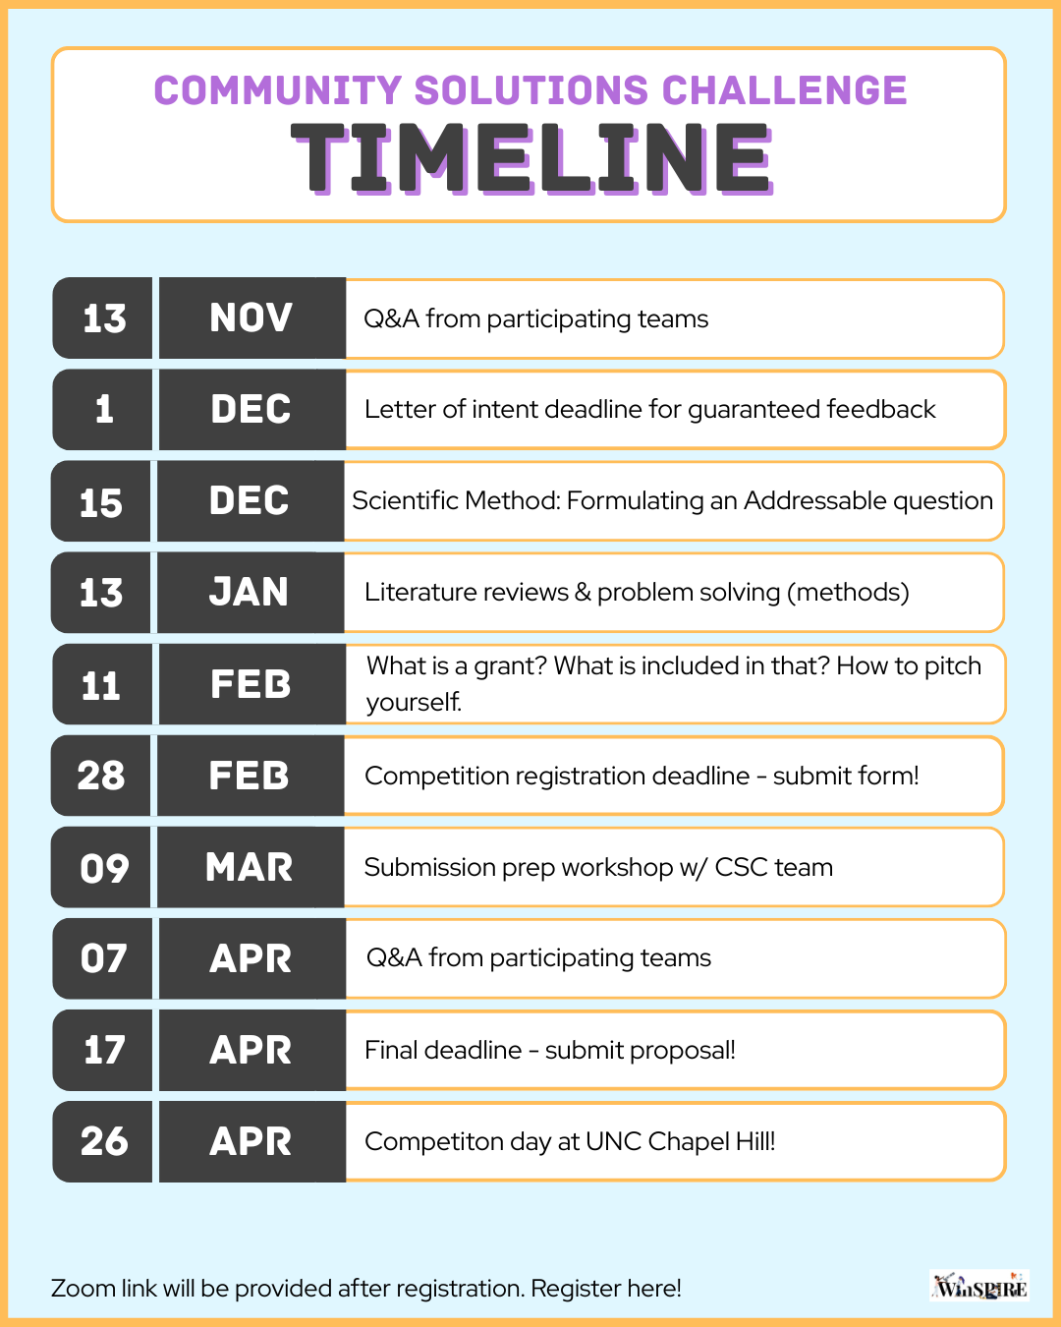

Competition winners & teams who participate all year:
- Competition winners will be determined by a panel of judges on the competition day. Teams will be judged in the context of their proposals, keeping in mind that every category and project will be unique. Projects will be evaluated by a topic-agnostic rubric (this will be made visible at the start of the spring semester). Winning teams will receive recognition at the final competition, and their proposals will be featured on the WinSPIRE website.
- Team participation: Teams that are able to attend 75% of the workshops live and participate in the final competition will receive a WinSPIRE Community Solution Challenge Certificate of Completion. This certificate recognizes the dedication and hard work these teams put in to further their scientific education in an impactful way.

AI Policy:
The heart of the UNC-CH WinSPIRE Community Solutions Challenge is based on the ideation of unique problems within North Carolina communities. Therefore, competitors are prohibited from using AI to any extent. AI should not have a hand in any part of this project. This means AI software cannot be used in any sort of ideation, implementation, or creation process. Participants are required to brainstorm problems in their community and think of and create the solution themselves. To be eligible to participate, participants MUST sign the honor code statement that makes it clear that they will not use AI in any part of their project. However, that does not mean participants are forbidden from using resources on the internet like search engines or scholarly websites.

FAQs

I am a high schooler at a registered high school but am not of high school age. Am I still eligible to participate?
Yes, participants are still eligible to participate if they are not of high school age, if and only if they are in a registered North Carolina High School. This, however, does not apply to homeschooled students. Homeschooled students must be within the high school age range (14-18).

How will we communicate with you?
All information regarding workshops, competition materials, deadlines, reminders, or logistics will be sent to the team’s registered advisor (as listed in the registration form). The advisor must satisfy the requirements stated in this rulebook's eligibility section. It is the responsibility of the advisor to relay the information we send out to the participants.

I cannot attend every single workshop on the dates and times stated. Are they mandatory?
It is okay if you cannot attend every workshop. Recordings of the workshops will be provided shortly after each workshop. Each workshop will be an hour and a half long.

How is attendance being tracked for Team Certificates?
Each team will enter the meeting room online with their school's name, and attendance will be tracked as such. If teams cannot get together, each participant will have the name of their school as well as their name. In the case of multiple school teams, we will designate numbers (Example: School A1, School A2). We will be recording attendance in the first 15 minutes and last 20 minutes of the session. To receive the certificate, you must attend 75% of all workshop sessions (not including Q&As).

I joined after the letter of intent feedback deadline; am I too late to attend workshops?
Nope! Competitors who register after the December 19th deadline will still be able to attend workshops that occur after they register. It is important to note, to be able to attend future workshops, they MUST register at least 24 hours before the upcoming workshop. However, they will still have access to past workshops as they will be recorded and posted on our website.

What is the difference between a letter of intent feedback deadline and the registration deadlines? Will they affect my score at the competition?
The letter of intent deadline is meant to be an earlier deadline for participants to submit their letters of intent in the fall so they can get mentor feedback. The registration deadline will also be a time for participants to submit their letters of intent; however, they will not receive mentor feedback as it is much later in the competition stage. It is important to note that submitting during the priority deadline is truly optional. The sole act of submitting letters of intent during the priority deadline will not affect scoring. However, we do recommend participants submit early so they can receive mentor feedback.

Do I need to submit my registration forms along with my LOI for the December 19th Deadline?
It is strongly recommended to have registration forms completed BEFORE the December 19th deadline. Even if you do not plan to submit on the LOI Feedback deadline, submitting registration forms at least 24 hours before a planned workshop date ensures that you can attend the workshop series and get valuable information. However, you can also submit your registration forms along with your LOI for the LOI feedback deadline. This ensures that participants will be eligible to participate in any workshop that happens after this deadline.

How are the winners chosen?
A winner will be chosen (either team or individual) based on judge scores on a pre-determined rubric. The rubric will be released in the spring semester. Participants can review the rubric and make changes as needed. The solutions will be judged based on how well the team or individual presents a solution based on the context of their problem. The highest scoring project, irrespective of category, will be the winner.

